Nama : Andri Firman Saputra  
NIM : 201011402125  
Kelas : 03TPLP016  
Tugas : Digital Marketing – Tugas Harian 1

dePlaza.id

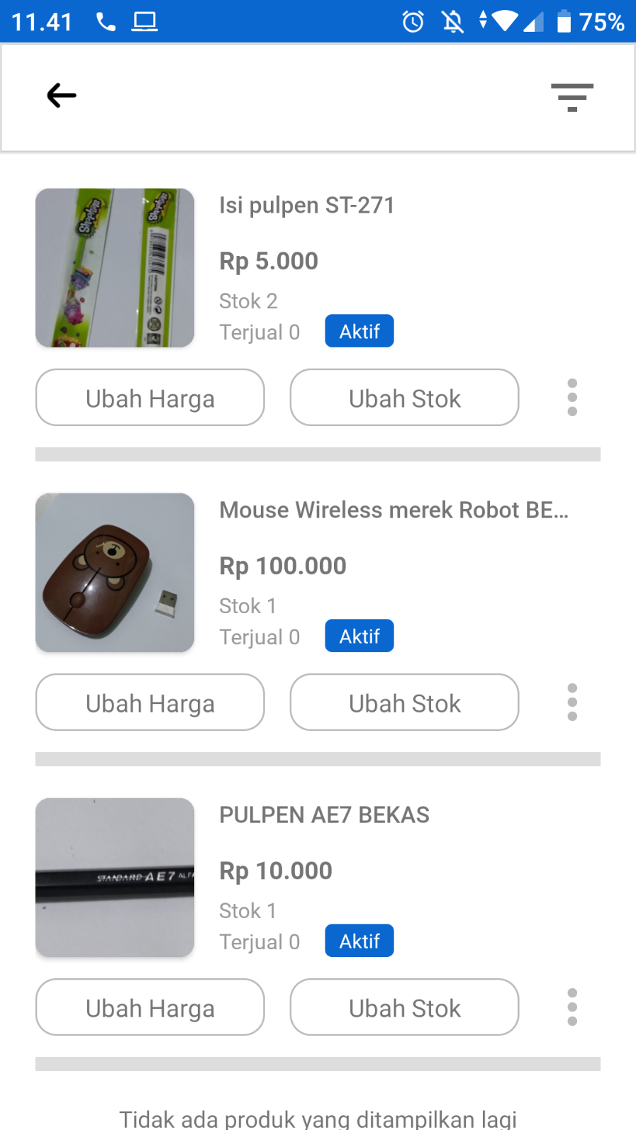

Facebook Marketplace

<https://www.facebook.com/marketplace/item/1109236626516190/>

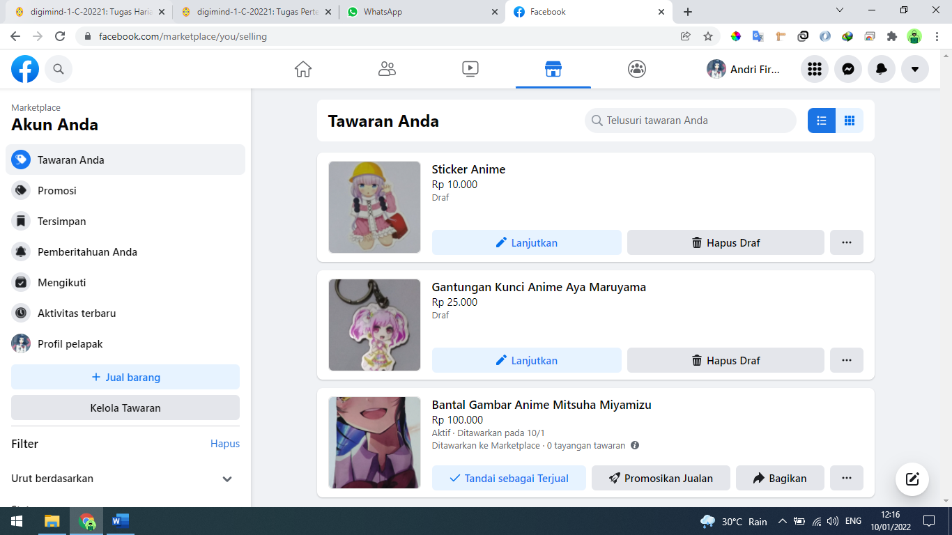

Instagram

<https://www.instagram.com/assassiniruna/>

